Explore Wonderful Korea!

❑ Seoul City Tour
1. Gyeongbokgung Palace
  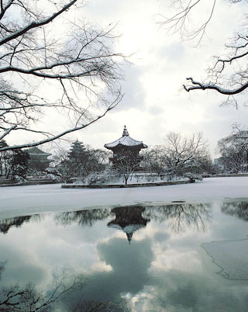
  Gyeongbokgung Palace
  Address
  Seoul, Jongno-gu, 1 Sejong-no
  Type
  Palaces/ Fortresses/ Gates
  Inquiries
  -Travel phone +82-2-1330 (English, Korean, Japanese, Chinese)
  -Administration Office +82-2-732-1931 (Korean) - +82-2-734-2457 (Korean)
  Homepage
  http://www.royalpalace.go.kr/ (English, Korean)

Introduction
Built in 1395, Gyeongbokgung Palace is also commonly referred to as the “Northern Palace” because it is located more toward the north, compared to the neighboring palaces of Changdeokgung (Eastern Palace) and Gyeongheegung (Western Palace). Gyeongbokgung Palace is arguably the most beautiful and remains the grandest of all the five palaces.
The premises were destroyed by fire at the time of the Japan's occupation of Korea during 1592-1598. However, all of the palace's 7,700 rooms were later restored under the leadership of Heungseondaewongun in the years of King Gojong (1852~1919) .
Remarkably, the most representative edifices of the Joseon Dynasty, Gyeonghoe-ru Pavilion and Hyangwonjeong Pond are still relatively in tact. Woldae and the sculptures of Geunjeongjeon (The Royal Audience Chamber) represent the past sculpture art which was the trend back then.
The National Palace Museum of Korea is located south of Heungnyemun Gate, and the National Folk Museum is located east within Hyangwonjeong.
*Ticket passes for Gyeongbok Palace can also be used at the National Palace Museum and the National Folk Museum.
Closed
Every Tuesday
Admission Fees
Classification | Age 19- | 7-18
Individual | 3,000 won | 1,500 won
Group | 2,400 won | 1,200 won
* Age 6 or under are free.
* Groups are more than 30 persons (age 19-) / more than 10 persons (7-18).
Interpretation Services Offered
In front of information center, Hongryemun Gate (main gate)
* English: 9:30, 12:00, 13:30, 15:00
* Japanese: 9:30, 10:30, 13:00, 15:00
* Chinese: 10:00, 12:30, 14:30
Local Transportation
1. From Exit No. 5 of Gyeongbokgung Subway Station (Seoul Subway Line No.3), walk 5 minutes.
2. From Exit No. 2 of Ganghwamun Subway Station (Seoul Subway Line No.5), walk 5 minutes.

2. National Folk Museum of Korea

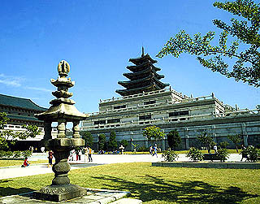
Address
Seoul-si Jongno-gu Sejong-ro 1-1Beonji
Inquiries
- Korea Travel Phone +82-2-1330 (Korean, English, Japanese, Chinese)
- For more info +82-2-3704-3114 (Korean, English, Japanese, Chinese)
Operating Hours
* March - April and September-October : 09:00-18:00
* May - August : 09:00-18:00 / Saturdays, national holidays : 09:00-19:00
* November - February: 09:00-17:00
(Visitors may enter up to 1 hour before closing time.)
Closed
Every Tuesday, New Year's Day

Introduction
The National Folk Museum displays the lifestyle of ancient Koreans. There are 20,000 vestiges, with a total of 4000 folk relics. In the Center Hall there are traditional cultural or folk related exhibits. The “Hall of Korean Lifestyle” shows the lifestyle of Koreans from pre-historic times to the Joseon Period (1392~1910). You can compare the cultural characteristics and vestiges by period and you can see the development of pottery, agricultural implements and prints.
The 2nd Exhibition called ‘Hall of Koreans at Work‘ displays tools for farming, hunting, fishing, along with clothing and houses. It includes handicrafts, accessories, dishes, kimchi and jangdokdae.
The 3rd Exhibition is called the ‘Hall of a Korean Life Cycle‘ and presents the life of an ancient Korean from birth to marriage to death. The exterior of the museum is more interesting than interior. Jejudo Island sculptures such as Dolharubang, windmills, treadmills and sheds are displayed outdoors. The National Folk Museum holds a ‘Korean Folk Concert’ every Saturday at the auditorium. The National Folk Museum designates the first Sunday of every month as ‘Visit the Museum’ day and the admission fee is waived.
Admission / Participation Fees
Free for all visitors
* If you visit Gyeongbokgung palace, please purchase a ticket at the Gyeongbokgung ticket office.
- Age 19~64 years old: 3,000 won(2,400 won)
- Age 7~18 years old: 1,500 won (1,200 won)
* ( ) for group fee
- Adult groups if more than 30 persons.
- Teenager groups if more than 10 persons.
- Educational participant- Check in at the front gate and enter with a guardian.
- Visitors wearing Korean traditional clothes (Hanbok)
* You can enter National Folk Museum of Korea, Gyeongbokgung, and National Palace Museum of Korea with only one ticket (You cannot enter the National Palace Museum of Korea free on Monday, which is usually closed).
* No participation fees.
- Age: under 6 years old and above 65 years old
- The disabled and one guardian
- Every second and fourth Saturday : Free for elementary/middle/high school students
Parking Facilities
The National Folk Museum of Korea does not have its own parking lot. Please use the Gyeongbokgung facility nearby.
□ Location
From Gwangwhamun, take the street toward Samcheong-dong and the parking lot is on the left side. (Refer to the map for visitors arriving in automobiles)
□ Parking Charges
· Small vehicles (16 or fewer persons) : W2,000 for first 2 hours, W500 for every 15 minutes after
· Mid-/large-sized vehicles (more than 16 persons) : W4,000 for first 2 hours, W500 for every 15 minutes after · For more information, call +82-2-725-4503
Foreign Language Intepretation Services
□ Museum Tour Guides (Korean, English, Japanese)
□ Automated voice information system
- Korean, Enlgish, Japanese, and Chinese
- Fare: 1,000 won ☎ 02) 3704-3066
(Please make reservations in advance)
Directions
(Map : www.nfm.go.kr)
□ Subway
Line No. 3: Gyeongbokgung Station, Exit 5
Line No. 3: Anguk Station, Exit 1
Line No. 5: Gwanghwamun Station, Exit 2
Line No. 1: Get off at Seoul Station and take a shuttle bus(Samcheong Transportation) bound for National Folk Museum of Korea
□ Intracity Bus
Takes 15 minutes from Sejong Road bus station by foot.
□ Shuttle Bus
Seoul Station (10~15 min intervals)/Samcheong Transportation→ City Hall(the other side of Samsung Building) → Press Center → KT Corporation → National Palace Museum of Korea → National Folk Museum of Korea
□ Seoul City Tour Bus
- National Palace Course
9 a.m ~ 7 p.m / 30 min intervals / 10,000 won for whole day / Mondays off / discounts for elementary/middle/high school students
※ For more information about stops >>> www.seoulcitybus.com
□ From Incheon Airport
- Take the airport limousine bus and get off at Seoul Station or City Hall. Then take the shuttle bus.
- Take the bus No. 601, 602 602-1 and get off at City Hall. And take a shuttle bus and get off at Gwanghwamun or Gyeongbokgung. Walk about 15 minutes and then you will find it.
□ From gimpo Airport
- Subway Line No. 5: Get off at Gwanghwamun Station, 15-minute walk from KT Corporation or Ministry of Culture and Tourism Building
- Take the airport limousine bus and get off at Koreana Hotel(Gwanghwamun crossroads), 15-minute walk
- Bus bound for Gwanghwamun(No. 161, 601), get off at donghwa dutyfree shop(Gwanghwamun crossroads) and walk for 15 minutes.
• Subway
-Gyeongbokgung Station (Seoul Subway Line 3) Exit No.5, walk 10 minutes.
-Gwanghwamun Station (Seoul Subway Line 5) Exit No.2, cross the street through a underpass. Then walk 5 min.
Homepage
www.nfm.go.kr (Korean, English, Japanese, Chinese)

3. Insadong
Insadong and the surrounding area were the residences of Joseon Dynasty (1392-1910) officials, extended royal families, and the yangbanaristocratic class.
The antique art shops that were established here during the Japanese Colonial Period carried everyday items of the privileged class as these items became antiques in the face of modernity.
Since then, Insadong has been home to dozens of art galleries and antique shops. Insadong's narrow alleys branch out into all directions from one main street.
To explore the interesting places on these side alleys, it would be helpful to get a map of Insadong at one of three Tourism Information Centers that are located at the center and the two ends of the main street.

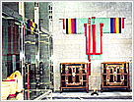 |  | Antiques  41% of Korea's antique shops. These shops display and sell quality antiques such as old paintings, ceramics, woodenware, metalware, old furniture and many other items. Among them, ceramics are found abundantly. Numerous antique shops are renowned for specific merchandise: Tongmungwan for old documents, Haedonggodoja Research Institute for ceramics, Godosa for daily utensils of the past, Dongmundang and Gonghwarang for calligraphy supplies, and Naraksil and Gayajae are famous for old furniture.

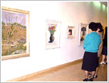 |  | Art Galleries  Art galleries began to settle in Insadong from the 1970's and presently account for more than 70 shops. Galleries in Insadong display and sell modern art pieces as well as antiques. The price of artworks range from a few U.S. dollars to ten thousand U.S. dollars. Exhibitions are held frequently in these galleries and give good chances for Korean artists to gather. Insa Art Center and Gyeongin Art Gallery are famous in Insadong.

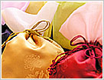 |  | Hanbok Korean Traditional Clothes, Ceramics, Handicrafts and Souvenirs  Most hanbok shops in Insadong sell a simplified version of hanbok. hanbok usually costs about two hundred U.S. dollars, but the price of high-quality hanbok could go up to a few thousand U.S. dollars. Jilgyeongyi Wuriot is a famous hanbok shop. Ceramics is another popular shopping item in Insadong. Good quality ceramics have a clean color and make a pure sound when tapping it with a finger.  Bakyeongsukyo is a prominent ceramics shop which even was visited by Queen Elizabeth �� of England. If hanbok or ceramics are too expensive, traditional-style daily items might be a good option. Wuri Segye, Sori Hana, and Tongin Gagye are good shops to get souvenirs such as silk pouches, oriental fans or mobile phone strings. Gana Art Shop inside of Insa Art Center offers traditional high quality items. Awon Gongbang is a good shop for metal crafted products and the National Souvenir Center and Seoul Souvenir Shop are specialized souvenir shops in Insadong.

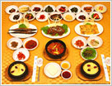 |  | Food and Drink  Most restaurants in Insadong are on alleys near Sudo Pharmacy. (Please refer to the map of Insadong.) Traditional restaurants in Insadong serve Korean dishes cooked without synthetic seasonings in remodeled traditional Korean houses. Sanchon serves good temple food along with a traditional performance. The Restaurant Jirisan Restaurant is famous for delicious dishes that taste of Korean home cooking. Sadongmyeonok is renowned for manduguk dumpling soup, Insadong Hangari Sujebi is recognized for sujebi clear soup with wheat flakes, and Gaetmaeul Milbatjip is celebrated for kalguksu noodle soup. Yetchatjip, Gwicheon, and Jeontong Dawon located inside of Gyeongin Art Gallery are popular traditional teahouses. A fun experience in Insadong is to try hotteok Chinese stuffed pancake or ggultarae from a street vendor.

4. Changdeokgung Palace and Huwon

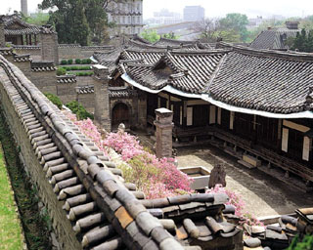
  Changdeokgung Palace...
  Address
  Seoul, Jongno-gu, 2-71 Waryong-dong
  Type
  Palaces/ Fortresses/ Gates
  Inquiries
  -Travel Phone +82-2-1330 (Korean, English, Japanese, Chinese)
  - +82-2-762-9513 (Korean)
  Homepage
  http://www.cdg.go.kr/main/main.htm (English, Korean)

Introduction
Changdeokgung Palace is the second royal villa built after Gyeongbukgung Palace in 1405. Chandeokgung served as the principal palace by many Joseon kings an remains the best preserved among the five royal Joseon palaces. The rear garden that was used as a place of rest by the kings boasts a gigantic tree that is over 300 years old, a small pond, and a pavilion. The palace grounds are comprised of a public palace area, a royal family residence building, and the rear garden.
The palace served as the main building after the 9th king of Joseoun, Seongjong, when a number of kings used this palace as a place of dwelling. However, the palace was burned down during the time of the Japanese Invasion of Korea in 1592. Angry citizens set fire to the palace when it was evacuated during the time of invasion. Thanks to Gwanghaegun, the palace was later restored in 1611, where nature and art now flourishes, quite a sight to see for tourists. The palace is filled with cultural assets such as Injeongjeon Hall, Daejojeong Hall, Seonjeongjeon Hall and Nakseonjae to visit.
The World Cultural Heritage Committee also designated Changdeokgung Palace as a World Cultural Heritage in December of 1997 in Napoli, Italy.
Changdeokgung’s rear garden was constructed during the reign of Taejong, and had served as a resting area for the royal family members. The garden was also called Bukwon and Geumwon, but after Kojong became king, he renamed it Biwon. The garden was kept as natural as possible and human hands were only used when absolutely necessary. Buyongjeong, Buyongji, Juhabru, Eosumun, Yeonghwadang, Bullomun, Aeryeonjeong, and Yeongyeongdang are some of the many pavilions and fountains that occupy the gardens. The most beautiful time to see the garden is during the fall when the autumn foliage is at its fullest peak and the leaves start to fall.
Closed
Every Monday
Operating Hours
1.Touring with a guide(takes 1 hour and 20 minutes)
2.Non-guided Tour will be available from June 15 2006 every Thursday.(costs 15,000 won).
Admission Fees
Age 19 and over: 3,000 won / Ages 7 to 18: 1,500 won / Age 7 or under are free / Non-guided Tour on every Thursday: 15,000 won
Non-guided Tour Information : April 12, 2007 ~ November 30, 2007(Every Thursday)
Fee: 15,000 Won
Etc: Voive guiding machines will be offered for free on the non-guided tour days. You need to show your identification if you borrow it.
Local Transportation
- From Exit No. 3 of Anguk Subway Station (Seoul Subway Line No. 3), walk toward Biwon for 2 minutes.
- From Exit No. 6 of Jongno 3(sam)-ga Subway Station (Seoul Subway Line No. 1 & 5), walk 10 minutes passing by Nakwon Store.

5. Mt. Namsan & N Tower
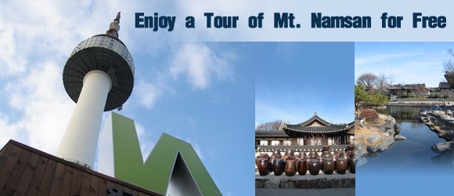
A "free tour site" appeals to everyone. Seoul's Mt. Namsan offers free tour courses that have not yet been discovered by many. To add to your Seoul travel experience, some of Mt. Namsan's free full-day tour courses have been recommended, especially for those of you on a tight budget. All you need to prepare is your camera, and some money for lunch and transportation.
Oh! Zemi-dong (오! 재미동) - Namsangol Hanok Village (남산골 한옥마을) - Lunch (Namsan Dongaseu, 남산 돈가스) - Cartoon Museum (만화의 집) - N Seoul Tower (Night View)
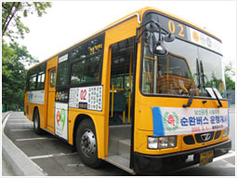 | How to use the Yellow Bus, Mt. Namsan's sole transportation method.  Since May of last year, all cars and taxis have been prohibited to enter Mt. Namsan to protect the environment. Instead, the Yellow Bus operates every 5 to 10 minutes, stopping at 9 major tour sites. The bus stops at Daehan Cinema, Toegyero 5 (oh)-ga, Dongguk University entrance, National Theater of Korea, N Seoul Tower, Namsan Library, Mt. Namsan Walkway, Seoul Animation Center and Toegyero 3(sam)-ga. The bus runs from 8 am to midnight, and the bus fare is ￦500 for the metro-card, and ￦550 if you use cash. The bus stops are announced in English for the convenience of foreign tourists.

Course 1 11:00~12:00 Relax at 'Oh! Zemidong'
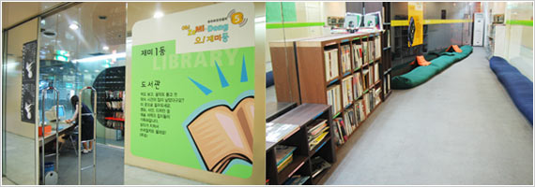

Course 1 begins at 'Oh! Zemidong' located inside Chungmuro Station of Subway Line No.3 and No.4. This cultural facility is open to everybody. The 'Oh!' in 'Oh! Zemidong' refers to the Korean number 5, which means this place has five types of fun. Foreign visitors will most likely find the video room and magazine corner the funniest.
The magazine corner has various movies-related reading materials, both domestic and international. You can also use the jukebox to listen to some music while reading. There are 40 types of magazines, mostly dealing with movies, design, cartoons, interior, travel, and fashion. The video room provides 400 movie selections ranging from movies and documentaries to animations. Each month, 10 to 20 new movies are added to the inventory. The screen is not very large, but the video room structure is unique. You can use the magazine corner and video room free-of-charge. However, you have to register as a member in order to use the video room. If you do not have much interest in movies, then move onto the next tour course.
[Detailed Information]
Opening Hours: 11:00~20:00/ Closed on Mondays
Location: Inside Chungmuro Station (Do not exit the subway, and follow the sign for Oh! Zemidong (오! 재미동), which is situated between the ticket gates.)

Course 2 12:00~14:00 Escape the City & Travel: Go to 'Namsangol Hanok Village'
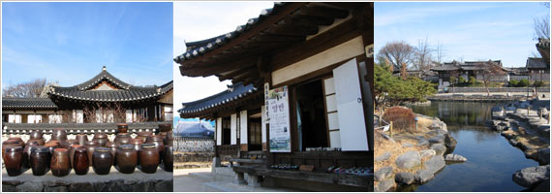

The next stop after Oh! Zemidong is Namsangol Hanok Village, situated near Chungmuro Station Exit No.4. The Hanok Village is a restoration of five traditional Korean houses from Joseon Dynasty taking you back to Korea's past, situated in the heart of Seoul among many tall, modern buildings.
The village is quite large, and requires about 1 to 2 hours to tour the entire village and the Time Capsule Plaza. The ideal final stop in the village is the 'Mangboklu' pavilion located on the hill behind Time Capsule Plaza, which provides an overall view of Namsangol Hanok Village and downtown Seoul.
Lunch awaits the finish of your tour of the village. Head to the Yellow Bus as you anticipate the taste of the famous Namsan Dongaseu (pork cutlet). Yellow Bus No.02 (refer to the chart below) stops near Exit No.4 of Chungmuro Station. Because of its color, you will recognize the right bus easily.
→ For more information on Namsangol Hanok Village, cllick here.

Course 3 14:00~15:00 A Generous Serving of the Delicious 'Namsan Dongaseu'
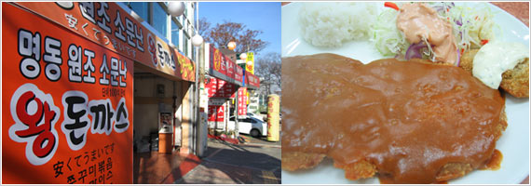

Once on the Yellow Bus, look out the window and enjoy the view of Seoul as its passes by. As the bus leaves the peak of Mt. Namsan behind (for now stay on the bus and enjoy a night view of Seoul after sunset), you will come upon the bus stop for Seoul Animation Center. Get off at this stop and walk across the overpass located to the center right (when you are facing the center entrance). Walk up the slope about 100m to reach the alley lined with Dongaseu restaurants.
Dongaseu (pork cutlet) has been a specialty of Mt. Namsan for a long time, frequented by taxi drivers who spread the word making it a popular area known for Dongaseu. The restaurants have been introduced in the media many times. The Dongaseu are hand-made from scratch, so the shapes might not be very pretty, but the taste is amazing. The prices and taste are similar, so you will not go wrong with any restaurant that you choose situated in this alley. The prices range between ￦5,000 and ￦6,000.

Course 4 15:00~17:00 'Cartoon Museum', the Cartoon-Mania's Heaven
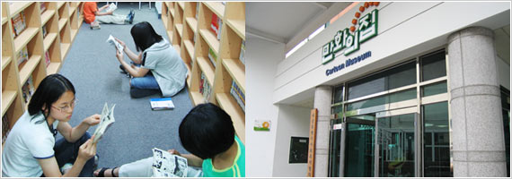

You may want to take a break and relax after lunch. Then, it's a good idea to head on into the Seoul Animation Center located near the bus stop you last got off at. Walk down the slope and you will find the entrance to the Cartoon Museum with cartoon character models erected at the its doors.
Cartoon Museum, which opened in 2002, is an affiliated facility with Seoul Animation Center. An average of 200 daily visitors come to the museum which provides approximately 27,000 materials. The museum houses a variety of cartoons, ranging from modern cartoons to 'classic cartoons' published in the 1980s.
If you like cartoons, then this museum will offer you a fun experience. If you don't know any Korean language, then browse through the cartoon books for a little bit, then head for the 'Cartoon Exhibition' located on the second floor. Displays of competition winners, cartoon character models, cartoon magazines, and more can be found in this room. Also, at the Video Information Center on the first floor of the main building (in front of the bus stop) you can watch not only Korean animations but also international cartoon videos. However, the Cartoon Museum and the Video Information Center requires you to show your identification card to enter.
[Detailed Information]
Opening Hours: 10:00~18:00/ Closed on Mondays & Holidays
It will be closed temporarily from 09:00 to 12:00 on March 9 (Fri.), 2007. Free admissions
Inquiries: +82-2-3455-8330 (Korean)
Website: www.ani.seoul.kr
Location: in front of Namsan Yellow Bus Stop 'Seoul Animation Center'

Course 5 17:00~19:00 Embrace the Night View of Seoul at 'N Seoul Tower'
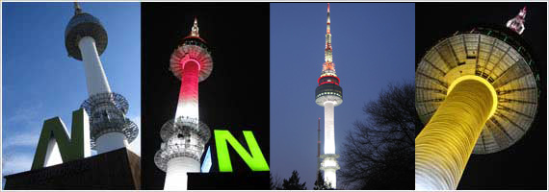

Today's tour course highlight is without a doubt the night view of Seoul City. You can reach the top of Mt. Namsan by three methods: either by taking the Yellow Bus (the bus operates in a circulating route, so you will have to pass Chungmuro Station again), or by walking up the hill, which you can use the stairway, or by riding the cable car. All three options have their own charm, but in the cold winter weather, the recommended choice is the 'quickest and most comfortable' way: the cable car! You will find it on the slope a little beyond the Dongaseu restaurant alley you visited for lunch. You will have to pay a moderate fee for a lift up (round-trip: ￦7,000, one-way: ￦5,500), but the night view of the surrounding areas of Jongro and Myeongdong is worth seeing.
It takes only 3 minutes to reach the top of Mt. Namsan (walk up a short flight of stairs to reach the N Seoul Tower). The N Seoul Tower is a must-see for those of you visiting Korea. The brilliantly lit N Seoul Tower is one of Seoul City's top tour sites. A lighting show begins at 6pm on the dot for 5 minutes every evening, so it would be ideal for you to reach the tower a little before 6 pm to enjoy the show.
Behind the tower, Seoul's night view spreads before your eyes. The headlights of moving vehicle, the lit skyscrapers and yellow street lights all come together to create a beautiful night spectacle. After taking in the magnificent night view, take the Yellow Bus to Daehan Cinema, which will bring your tour to a finish.
→ For more information on N Seoul Tower, cllick here.

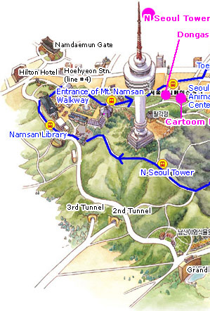 | 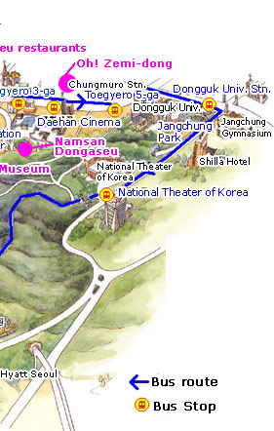

6. Namsangol Hanok Village
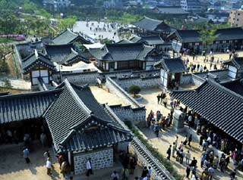
  Namsangol Hanok Vill...
  Address
  Seoul, Jung-gu, 84-1 Pildong 2(i)-ga
  Type
  Old Houses/ Birth houses/Folk Villages
  Inquiries
  -Travel phone +82-2-1330 (English, Korean, Japanese, Chinese)
  -Namsangol Hanok Folk Village +82-2-2264-4412 (Korean)
  Homepage
  http://www.hanokmaeul.org/ (English, Korean, Japanese, Chinese)

Introduction
If you get off at Chungmuro Subway Station, you are right in front of Namsangol Hanok Village(traditional Korean village). You may consider it interesting to find this area standing between the tall buildings. This village has restored five traditional Korean houses, with a pavilion, a pond and a time capsule which makes it a perfect spot to take a walk.
When you enter the front gate, you will see the vast valley and the Chunugak to the left of the pond. Along with the pond, it is a splendid place where performances are held. On the side you will see five traditional houses. These houses were rebuilt after the traditional houses of Joseon Dynasty. The houses belong to various social ranks of the society from peasant to king. The furniture in the house are situated to help guests understand the daily life of the past. The clean traditional houses and used home equipments are great to take pictures. If you would like to see souvenirs, stop at the traditional craftwork exhibit where you can buy small dishes and souvenirs. You can also have traditional tea and refreshments. On the grounds, there are traditional games you may want to try such as 'neolttwigi' (sea-saw jumping), 'tuho'(arrow throwing) and 'yunnori' (traditional game of throwing wooden yut sticks). In addition, you may not want to miss traditional marriage ceremony. During the weekends, traditional marriages are shown at Bak Yeong Hyo's Residence. The traditional marriage ceremony is an interesting event for both Koreans and foreigners and many gather to watch although it is not shown at certain hours. During the winter season (November to February), there are not many weddingceremonies held, as it is frequently held in Spring and Fall. Hours for the ceremony are held around noon or 1 p.m. Visitors can take pictures with husband and wife wearing traditional wedding costumes. Furthermore, there is also a time capsule in remembrance of Seoul’s 600 Year Anniversary. Buried in 1994, it is anticipated to open four hundred years later.
Closed
Every Tuesday (However, if Tuesday is a bank holiday, the next day is closed.)
Operating Hours
Mar.- 9a.m.-6p.m.
Apr./May/Sept./Oct.- 9a.m.-7p.m.
Jun.-Aug.- 9a.m.-8p.m.
Nov.-Feb.- 9a.m.-5p.m.
Admission Fees
Free
Local Transportation
• Subway - At Chungmuro Subway Station (Seoul Subway Line No.3 or No.4) Exit No.3 or No. 4, walk for 5 minutes. (Behind Chungang Univ. Affiliated Hospital)
• Bus - Take Bus No. 0013, 0211, 104, 105, 263, 371, 400, 604, or 7011. Get off in front of Geukdong Building at Twegye 3(sam)-ga.
Related Tour Packages
Yongsan electronics Market Tour (Cosmo 8)
Destination: Seoul
Duration: 1Day(s) 0Night(s)
Special Night Tour (Cosmo 41)
Destination: Seoul
Duration: 1Day(s) 0Night(s)

7. Korea House
Address
80-2 Pildong 2-ga, Jung-gu, Seoul
Description
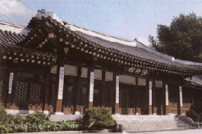
The Korea House was opened in 1981. It is a traditional Korean building that introduces the culture and lifestyle of Koreans where you can experience the traditional architecture and the classical atmosphere. The building was built after the Jagyeong-jeon building of Gyeongbok palace of the Joseon dynasty. It is the only building built in the traditional architecture style. You will feel the antiquity as you enter the building. It is divided into the Haerin-gwan (a space for people to get acquainted with each other), the folk theater, and the three annex buildings (Munhyang-ru, Nokeum-jeong and Cheongwu-jeong). At Haerin-gwan you can enjoy traditional music at Garak-dang and try traditional foods at Sohwa-dang. Especially in the square of Garak-dang you can view the traditional weddings or people playing folk games. If you visit on weekends, you will be able to see the traditional wedding ceremony. Also, at the Folk Theater, about 100 seats are ready and in the afternoons Human cultural Assets or members of the National Center for Korean Traditional Performing Arts and the National Corps members present traditional music and dances. Sinayui, Salpuri, Pansori, the Drum dance and the Bongsan Mask Dance are the most popular programs for foreigners. The programs are all explained in English and Japanese. In the Cultural Gift Shop you can view various crafts made by traditional craftsmen. It is always open and they are for sale as well. There are potteries, ceramics, golden crafts, knots and embroidery etc, approximately 500 pieces of artwork made by craftsmen from 20 different fields. Next to the House of Korea is the Namsan-gol Hanok village. You can view traditional houses there also.

Local Transportation
At Chungmuro station(Seoul subway line No.3 or 4) exit No.3. Walk towards the road of Pildong Hospital and then walk 2 min.
Take bus No.0013,0211,7011,104,105,140,263,371,400,604.
Detailed Info
1.Telephone : +82-2-2266-9101~3 (Kor/Eng/Jpn)
2.Homepage : www.koreahouse.or.kr (Kor,Eng,Chn,Jpn)
3.Folk Performance Hours : Part 1 - 7:00 ~ 8:00 p.m./ Part 2 - 8:50 ~ 9:50 p.m.
(On Sundays, part one is performed from 8:00 ~ 9:00 p.m.)
4.Open all year
5.Folk performance fee : 29,000 won
6.Facilities : Restaurant, Tea shop, Art shop.

8. The War Memorial of Korea
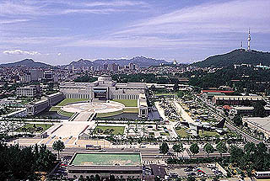
  The War Memorial of Korea
  Address
  8 Yongsan-dong 1(il)-ga, Yongsan-gu, Seoul
  Inquiries
  - Korea Travel Phone +82-2-1330 (Korean, English, Japanese, Chinese)
  - +82-2-709-3139 (English,Japanese,Chinese)
  Operating Hours
  Weekdays: 9:00—18:00
  Saturday: 9:00—21:00
  Closed
  Every Monday

Introduction
The grounds on which the War Memorial of Korea is built used to be the headquarters of the Korean Infantry. When the memorial was being built, many experts from different fields were consulted numerous times and exhaustive research done in order to complete the exhibits. This memorial, dealing with the subject of war, is the largest of its kind in the world.
You can visit 8 exhibits when you come to the War Memorial: the Hogukchumo Exhibit, War History Exhibit, June 25 War Exhibit, Overseas Dispatched Troops Exhibits, Military Development Exhibit, Large Equipment Exhibit, Outdoor Exhibit, etc. The Hogukchumo Exhibit honors the spirit of those who perished fighting on the battlefront. And you can learn all about Korea’s war history by visiting the War History Exhibit, June 25 War Exhibit, Overseas Dispatched Troops Exhibits, and the Military Development Exhibit, as well as witness how the Korean military developed over the years. Different kinds of weapons and large military equipment are exhibited as well, inside and outside the building.
The exhibit inside the building displays the equipment during the Korean War in such a way as to invite comparisons between the items. Large weapons and equipment used by different countries during World War II and the Vietnam War are also displayed. In the Large Equipment Exhibit on the second floor, many kinds of defense industry equipment and both real and model weapons are displayed. In the Bangsan Equipment Exhibit, you can look at weapons and war equipment produced in Korea. In the War Memorial’s Storage Room, 17,800 files and artifacts of war are preserved. Modern damage control and prevention devices have been installed to keep these materials safe from harm.
Besides these, you can also visit the Miniature Exhibit or the Peace Hall. There is a lecture hall at the memorial, and many lectures to do with war are held here as well. If there are books you want to read on war matters, you can head over to the bookstore in the memorial. You can find military books and pamphlets there. They also sell military souvenirs, so if you are interested, be sure to pay a visit. The memorial also has a fast food restaurant and stores outside the building.
Admission / Participation Fees
Adults: 3,000 won / Students: 2,000 won / Kindergarten: 1,000 won
(Group Tours: Adults 2,000 won, Students 1,500 won, Elementary Students 1,000 won)
Intercity Transportation
Local Transportation
Get off at Samgakji Station (Seoul Subway Lines 4 and 6), Exit No.12,and walk 5 minutes.
Homepage
www.warmemo.or.kr (Korean, English)

8. The National Museum
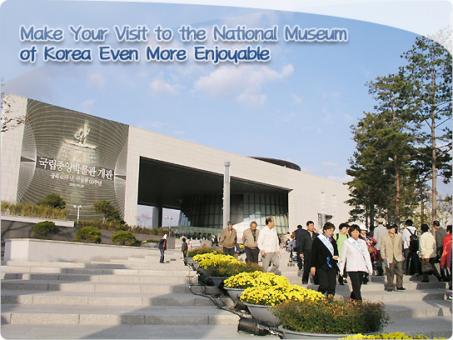
On October 28th, the doors to the National Museum of Korea reopened to the public and ever since then, tons of visitors come in and out these doors on a daily basis from the time it opens to the time it closes. It’s been a huge success since its reopened. The first day had over 19,100 visitors, the following day, Oct. 29, had a record of 35,300 visitors, and on Sunday, Oct. 30, a total of 41,500 people came to visit the museum. On the fourth day, which was a Monday, there were 20,800 visitors. During the first four days of its reopening, the museum had more than 116,000 visitors.
What could explain this phenomena; this exodus of visitors? Is it because it’s free and people just want to get in from the cold? It does imply something; that the public has a fond interest and appreciation for Korean history and culture. After 8 long years, this museum, one of the world’s 6th largest museums, finally reopened its doors and reintroduced itself to the public. Whatever the reason may be, the National Museum of Korea is overjoyed at the large crowds gathering at its doors.
☞ The Museum’s Layout
The National Museum of Korea is composed of the main exhibition areas for permanent exhibitions, and an area for non-permanent exhibitions. It also offers a ‘Children’s Museum’to provide an educational atmosphere and hands-on experience for children to enhance their understanding of exhibited works. The Museum also has an outdoor garden exhibiting various Buddhist stone structures. In total, the Museum is comprised of four major exhibition areas.
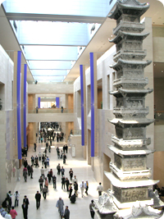
☞ Your Enjoyment Triples at the Exhibition Halls
Permanent Exhibitions
The Museum’s permanent exhibition galleries consist of three floors, and as you enter the Museum, a long hall lies straight across to the end of the Museum. This hall is the Historical Gallery, and it functions to divide the permanent exhibitions halls into the northern hall and southern hall. The ceiling allows soft natural light to flow warmly into the Museum. Along the Historical Gallery stands the Bukgwandaecheopbi Stone Structure, which was reclaimed from Japan one hundred years on Oct. 20, 2005. This stone structure is temporarily on display, and will be returned to North Korea in the near future, therefore if you wish to view this historical work of art, you should hurry and go see it at the Museum.
At the end of the Historical Gallery stands the Gyeongcheonsa Shipcheung Seoktap Stone Structure, high and proud. This work of art can be seen from any direction within the Museum. For a closer look you can take the escalator from the first floor to the third floor and view the structure.
The southern end of the permanent exhibition hall on the first floor holds the Archeological Gallery, displaying works from the Paleolithic period to the Unified Shilla Balhae. The northern end of the Historical Gallery holds nine exhibition halls displaying works from the Goryeo to Josun period. One of the most sought out exhibition halls in the Historical Gallery is the Balhae Exhibition Hall, which is newly on display since the reopening of the Museum. The most popular exhibition is in the Shilla Exhibition Hall in the Historical Gallery, and has a brilliant golden crown with a golden belt excavated from Gyeongju’s Hwangnamdaechong Bukbun.
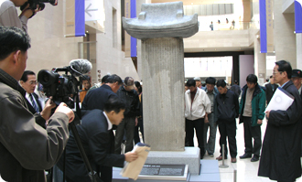 |  | 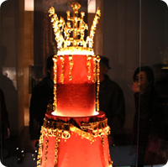
As you reach the second floor, the Fine Arts Gallery I and the Donations Gallery awaits. The northern end of the second floor is the Fine Arts Gallery which holds hieroglyphic works including calligraphy, hieroglyph, Buddhist calligraphy, and wood and lacquer works. The southern end of the second floor is the Donations Gallery which holds works donated by eleven donators.
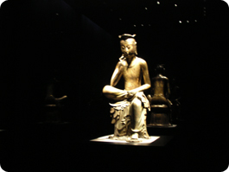 |  | 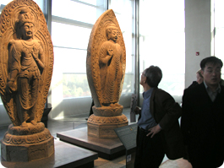
The southern end of the third floor is the Asian Arts Gallery, which is newly installed after its reopening of the Museum. The gallery holds major works of art from various Asian countries, consisting of Indonesian Art, Central Asian Art, Chinese Art, Nangnang Remains, Relics from Sinan Seabed, and Japanese Art. The Fine Arts Gallery II is on the northern end of the third floor, where works of White Porcelain, Buddhist Sculptures, and Metal Arts are on display. The Buddhist Sculpture Hall is very popular for its exhibited works because it shows the essence of Korean Buddhism and Buddhist sculpture. The most popular sculpture is the National Treasure No. 83, the Bangasayoosang.
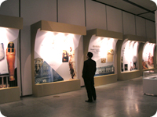
Non-Permanent Exhibitions
The non-permanent exhibitions exhibit a variety works from a variety of themes. It’s suggested that you stop by the non-permanent exhibitions on your way out from the permanent exhibition halls.
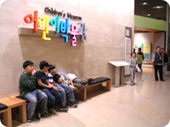
Children’s Museum
The Children’s Museum focuses on offering hands-on experience for children and teachers. For the children who are always hearing “please do not touch” almost everywhere they go, this museum is like paradise for curious children. Because this museum’s focus is on a hands-on experience, there is a limit to the number of visitors allowed in at a single time. At the ticket office, you’ll be informed of what time your admissions ticket is; therefore it is wise to check the time.
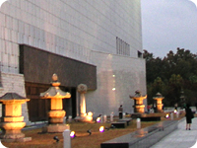
Pagoda Garden (Outdoor Museum)
The Pagoda Garden displays a total of ten national treasures, including the Boshingakjong Bell, stone pagodas, stone monuments, and more. You can enjoy viewing these works while taking a relaxing stroll in the outdoor garden.
TIPS for the Spectators

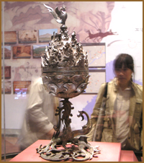
① No Time? Be Selective!
The permanent exhibition halls have been divided into smaller galleries to allow the visitors to pick and choose the galleries they wish to view. The Museum is very large in scale; therefore even a quick browse through the Museum could take more than eleven hours. Thus, it may be wiser for visitors to select the exhibitions they are interested in. The National Museum of Korea offers a variety of tour courses including Top 50 Works, and Top 100 Works. Log on to the museum’s homepage to download the directions of the tour course you would like so that you may enjoy the best of what the Museum can offer you within a short period of time. The Museum also offers tour courses for children, and theme courses.
② For the Meticulous Spectator, Invest More Than One Day.
“Instead of trying to see the entire Museum in one day, come back several times and take time to enjoy all that the Museum has to offer,” says Lee Geon Moo, director of the Museum. As Lee suggests, if you want to see the entire museum in detail, it will take more than one day. Just the Archeological Gallery and Historical Gallery alone takes at least six hours to view. A recommended course is to view the Archaeological Gallery, then take a coffee or snack break at the café near the Gyeongcheonsa Shipcheung Stone Structure. Next, look around the Historical Gallery, and move on to the Donation Gallery, and last but not least, view the non-permanent exhibitions. This will take a full day. On the second day of your visit, look around the second floor of the Museum; enjoy some snacks and drinks at the Food Court or the restaurants or cafés, then move on to the third floor. Afterwards, you can take a stroll through the outdoor museum at the Pagoda Garden. A walk by the nearby lake is also a recommended course at the Museum for a fresh breath of air and relaxation.
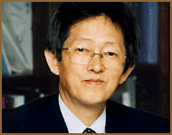
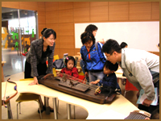
③ The Children’s Museum is a Must-See for Child-Visitors [Children].
If you are visiting the Museum with a child, then it is strongly recommended that you visit the Children’s Museum. To add to your child’s learning experience, it is recommended that you go on the tour courses offered by the Museum.
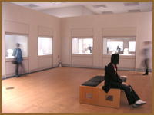
④ Don’t Rush Through, Relax and Enjoy.
In the National Museum of Korea, many areas for relaxation have been installed for visitors. To avoid weariness while walking around the Museum, take some time to sit and relax leisurely at the various relaxation areas provided by the Museum.
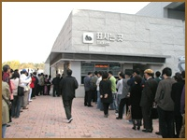
⑤ 3 Ticket Offices to Choose From.
The line waiting to receive the free admissions ticket is anywhere between a couple meters to several hundred meters. However, visitors tend to gather at the ticket office by a Café called “Mannam” and the ticket office in front of the non-permanent exhibition hall. So, to avoid the long lines, you can stop by the ticket office, which is located near the Reflecting Pond.
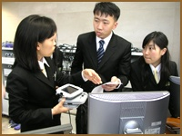
⑥ Let the Digital Guide Escort You.
The National Museum of Korea offers a PDA and MP3 tour guide for ₩3,000 and ₩1,000. When you stand in front of the work of art, the guide will begin to give explanations about the work, and the PDA also acts as a GPS function. You can rent these digital guides by the Information Desk in front of the permanent exhibition halls. You need to fill out a form first to rent these digital guides. They are offered in English, Japanese, and Chinese, which makes it convenient to tour and understand the displays at the museum.
⑦ Don’t Be Afraid to Use the Information Desk.
At the Information Desk, friendly guides are ready and waiting to answer any questions you might have in English, Japanese, and Chinese. A museum introduction pamphlet in the three languages is also provided at the Information Desk. Feel free to use this service provided at the Information Desk.
▒ Exhibits Do Not Appreciate This!
1, Please do NOT use your FLASH when taking photographs.
2, NO food or drinks are allowed in the exhibition halls.
3, Do NOT touch the plexiglass windows surrounding the exhibits or the exhibitions.
▒ Detailed Information
Address : 168-6 Yongsan-dong 6 ga, Yongsan-gu, Seoul, Korea
Phone : +82-2-2077-9000 (English, Japanese, Chinese)
Homepage : http://www.museum.go.kr (Korean/English/Japanese/Chinese)
Admissions(20 or more for group admissions)
1, Free Admissions from Oct. 28 – Dec. 31, 2005
2, From Jan. 1, 2006
Adults (Ages 19-64) : Individual - ₩2,000 / Group - ₩1,500
Children (Ages 7-18) : Individual - ₩1,000 / Group - ₩500
* Admissions for the Children’s Museum: Ages 7-64 ₩500
* Free Admissions for visitors under the age of 7 or above the age of 64.
Opening Hours
Weekdays: Tuesday – Friday : 09:00 – 18:00
Weekends: Sat, Sun, Holidays : 09:00 – 19:00
* Ticket Office Hours : Open until 1 hour prior to Museum’s closing hour
Closed : Every Monday starting from January 2006
Free Admissions : Every fourth Saturday starting from Jan. 2006
Group Admissions : Internet reservations required 1 week prior to visit
* Group of 20 or more. The maximum number of reservations per day is 3,600 persons
>> Link to detailed Information of the National Museum of Korea

9. 63 City
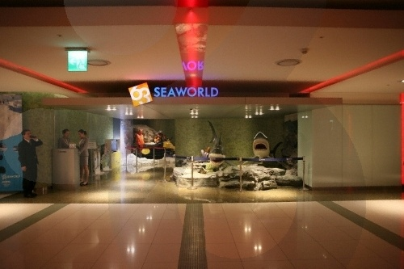
Address
Seoul Yeongdeungpo-gu Yeoido-dong, 60
Type
Architectural & Sculptural Highlights
Inquiries
- Korea Travel Phone +82-2-1330 (Korean, English, Chinese, Japanese)
- For more info : +82-2-789-5679 (English, Japanese)
Homepage
www.63city.co.kr (Korean, English)

Introduction
With 63 floors measuring a height of 264m, the 63 Building is Korea’s tallest and most recognized building. The 63 Building boasts spectacular views of the Hangang River and the surrounding mountains of Bugaksan Namsan and Gwanaksan.
63 Building has undergone considerable renovation and the basement floor boasts convenient facilities including 63 Sea World, 63 Sky Deck, 63 IMAX theater, Korea’s greatest buffet restaurant “Buffet Pavilion,” and a host of other restaurants.
Closed
No closings
Activity Information
* 63 Sea World
Basement first floor 16,119 square feet, basement second floor 16,724 square feet, and basement third floor (technology room) 5,515 square feet, totaling 38,358 square feet. Within this large-scale space, there are 54 regular aquarium displays, 26 special organism breeding aquariums, and other aquariums adding up to 80. In addition, specially created aquarium is 2m 10cm in height, 42m in circumference, water capacity of 200tons, and 11cm of transparent acryl. Other than aquarium displays which consist of 400 different kinds of over 20,000 of water organisms, there are also reptiles exhibitions and event hall is separately located in 63 Sea World in order to present unique ocean scenes. Ocean Family Show (seal, fur seal, diver show) can only be enjoyed at 63 Sea World. It is very unique and extraordinary which interests the audience presenting interesting scenes.
* 63 Sky Deck
63 Sky Deck, many visitors come every year, is 264m above the sea level, and 249m above the ground level is providing feelings as if floating above the clouds. Together with Han River’s water flow and view of the city lead it to be Korea’s representative tourist route. In addition, Sky Deck’s recreation facilities provide unique experience for the visitors and its various special exhibitions provide educational and cultural learning.
*63 IMAX theater
63 IMAX theater is Korea’s the first IMAX theater which opened in July, 1985 with 504 seats. There are eight special seats for handicapped audiences and simultaneous interpretation services are available in four different languages. Surround sound system is used; there are six vast speakers in the front and two in the back for the best quality of sound. 63 IMAX theater is international standard size of six floor building and its film is ten times the regular movie, 35mm, providing three times the 70mm movie.
Operating Hours
* 63 Sky Deck
10:00 ~ 24:00 (last admission 23:00)
* 63 Sea World
10:00 ~ 22:00 (last admission 21:30)
* 63 IMAX theater
10:10 ~ 21:00, screening hours 40mins
last screening 20:10
(Sat, Holidays 21:10)
* 63 Sky Deck two-way night pass use (purchase available from 19:00)
19:00 ~ 24:00 (last admission 23:00)
* 63 Sea World two-way night pass use (purchase available from 19:00)
19:00 ~ 22:00 (last admission 21:30)
Admission Fees
Refer to the homepage (English)
Directions
Take Olympic highway to enter Yeoui-do then right away make a left to enter the parking lot
Local Transportation
* By Subway + Shuttle Bus
① Go to Daebang station, subway line no. 1 and take the Free Shuttle or bus no.62 40m away from exit no. 6 towards Yeoido
② From subway line no. 5 Yeouinaru Station, take the Free Shuttle across from Sambu APT, 80m away from exit no. 4
③ From subway line no. 5 Yeoido station, take the Free Shuttle or bus no.62 in front of St. Mary’s Hospital Platform from exit no. 5
* By Bus
Take bus no. 362, 7611, 5534, 62, 9409
* By Airport Bus
① Incheon International Airport ↔ 63 Building
② Gimpo Airport, Incheon International Airport ↔ 63 Building ↔ Jeongju Iksan
* Service Hours : 05:20 – 23:10 (20-minute intervals)
Free Shuttle Bus Daebang Subway Station(in front of exit no.4), Yeouinaru Subway Station (in front of ext no.4), Yeouido Subway Station (in front of exit no.5), 63 Building (East lobby)

10. Hangang River Ferry Cruise
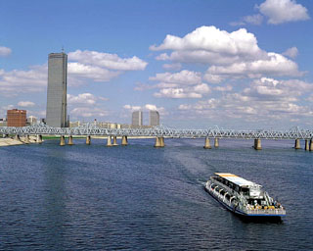
  Hangang River Ferry ...
  Address
  Seoul, Yeongdeungpo-gu, 85-1 Yeouido-dong
  Inquiries
  -Korea Travel phone +82-2-1330 (English, Korean, Japanese, Chinese)
  -Han River Land Tel +82-2-3271-6900 (Korean)
  Homepage
  http://www.hanriverland.co.kr/aboutus/group.html(Kor)

Introduction
“The Night Lights Of Seoul”
Hangang River Ferry Cruise is one of the best ways to enjoy the scenery around Hangang River that flows through Seoul. Cool wind from the river, the surrounding scenery, which get more beautiful in the evenings, are the rewards the ferry cruise can offer you. Currently there are six ferry cruises, going from Yanghwa to Jamsil, and they all operate throughout the year. There are 4 places to get on or get off the ferries: at the Yeouido, Jamsil, Nanji, and Yanghwa docks. All rides run on two kinds of cruise schedules. One cruise leaves the dock, goes on the Hangang River cruise course, and comes back. The other course starts from either Yeouido, makes a stop at Ttukseom Island, then ends at Jamsil. The alternate route starts from Jamsil, makes a stop at Ttukseom Island, and finishes at Yeouido. On the cruise, you can see Hangang River’s beautiful scenery, the surrounding islands, Jeoldusan Park, the 63 Building, Namsan Tower, Jamsil’s Multi Sports Complex, and other famous tourist spots. The cruise is often used for weddings, birthday parties, music performances and other events. The live concerts connect piano playing with singing voices, and will live on in memories. During the summer, the docks also offer motor boat rentals.
Program Activities
Ferry Cruise Fee
Course 1: Return Ferry
Course | Travel hour | Fee
Yeouido-Yangwha-Yeouido | 1 hour | 9,000 won
Yangwha-Han river bridge-Yangwha | 1 hour | 9,000 won
Nanji-Yeouido-Nanji | 1 hour | 9,000 won
Jamsil-Hannam bridge-Jamsil | 1 hour | 9,000 won
Yeouido-Yeouido (Live course) | 1 hour and 30 min | 13,000 won
*50% discount of adults fee for Age 13 and under
Course 2 : Depart from a dock and get off at a different dock.
Course | Travel hour | Fee
Yeouido-Jamsil | 1 hour | 9,000 won
Jamsil-Yeouido | 1 hour | 9,000 won
*50% discount of adults fee for Age 13 and under

Public Transportation within the Area
1.Yeouido dock>>Take Subway Line 5 and get off at Yeouinaru Station. Go to Exit No. 3 and walk 5 minutes.
2.Jamsil dock>> Take Subway Line 2 and get off at Sincheon Station. Go to exit No. 7 and walk 15~20 minutes
3.Yangwha dock>> Subway – Take Subway Line 2 and get off at Dangsan station. Go to Exit No. 5 and walk 20 minutes.(taxi takes just 5 min.)

11. Namdaemun Market
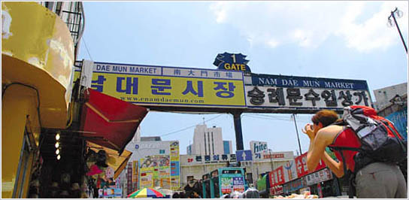
Namdaemun Market, located in the very center of Seoul, is the biggest traditional market in Korea selling children's clothing, men & women's clothing, daily miscellaneous goods, kitchenware and local and imported products. Most shops have their own factories and make the products themselves offering both wholesale and retail prices which enables visitors to purchase various shopping items at an extremely inexpensive price. Foreign visitors to Namdaemun Market show different features: the Japanese are more into foods like Gim (seaweed), Gimchi, and ginseng, while the Chinese show interest in clothing and miscellaneous goods. On the other hand, most tourists from the west simply enjoy the ambience of the traditional market. Hours vary by store, so it's advisable to plan out in advance according with a shopping list before you start the actual shopping.
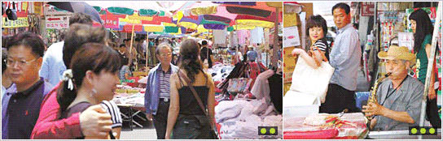
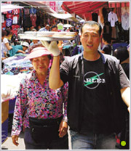

Without a moment to spare, this deliveryman knows all the right steps to make, meandering through the hustle and bustle to awaiting customers. In synch with the pulse of the market, it’s just another fine example at how everything blends beautifully together with supreme efficiency.
Such steady streams of intimate displays are just some of the many hallmarks to be found throughout Seoul’s market scene. Wonderfully symbolic, the richly colorful sea of parasols provide a fine way of enlightening the shopping experience and ensuring shoppers stay cool when stopping to get a better look at what catches the eye.
This eager saxophonist shares a few tunes for curious onlookers keen on taking in the traditional market experience. The gentle, airy harmonies really bring a new dynamic to the whole scene.

[ Transportation and Map ]
Seoul Subway Line 4, Hoehyeon Station Exit 5
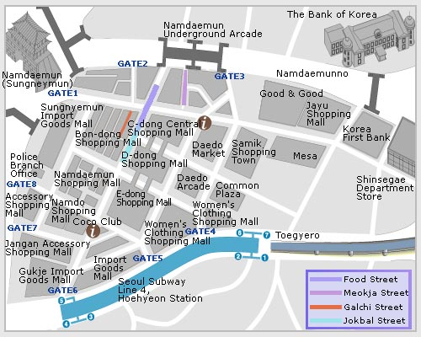

12. Bongeunsa Temple
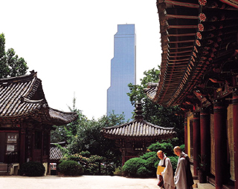
  Bongeunsa Temple
  Address
  Seoul, Gangnam-gu, Samseong-dong, No. 73
  Type
  Temples/ Religious Sites
  Inquiries
  -Korea Travel Phone +82-2-1330 (English, Korean, Japanese, Chinese)
  -Bongeunsa Temple Office +82-2-545-1448 (English, Korean, Japanese, Chinese)

Introduction
Once known as Gyeonseongsa Temple, Bongeunsa Temple is located to the north of COEX building, and was constructed in the 10th year of Shilla King Weongseong’s reign (794). In 1498, Queen Jeonghyeon refurbished Gyeonseongsa Temple at the east of King Seongjong’s royal mausoleum and renamed the temple as Bongeunsa. Originally located near the royal maulsoleum (1km southwest), the temple was transferred to its current location during Joseon King Myeongjong’s reign. 3,479 Buddhist scriptures of 13 types, including the works of Kim Jeong-hee, are stored here. The Buddhist ceremony called Jeongdaebulsa, is held every September 9th of the lunar calendar, where monks march carrying the scriptures on their heads and recite the Beopseongge (Buddhist rites).
Closed
None
Operating Hours
Usually set from 4a.m.- 9p.m. due to monks praying hours.
Admission Fees
Free
Local Transportation
1. By Subway:
- At Exit 6 of Samseung Subway Station (Seoul Subway Line No. 2), walk 100m toward Asem Tower, then turn left and walk through the Bongeunsa Temple trail. Beongeunsa Temple is located on the right. (10 minute walk)
- At Exit 2 of Cheongdam Subway Station (Seoul Subway Line No. 7), walk 150m toward Gyeonggi High School and turn right.
2. By Bus:
Take bus no. 361, 680, 2225, 2411, 2413, 3411, 3415, 4411, and 4428
Subway Info:
Samseong Subway Station (COEX) (line no. 2)

❑ Kyunggi-Do (at least 4 hour- distance for round trip)

13. DMZ, Imjingak
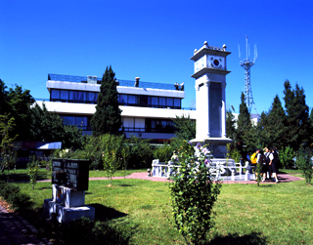
  Imjingak
  Address
  Gyeonggi-do, Paju-si, Munsan-eup, 1325-1 Majeong-ri
  Type
  DMZ Tours
  Inquiries
  -Travel Phone +82-31-1330 (Korean, English, Japanese, Chinese)
  -Imjingak Tourist Information +82-31-953-4744 (Korean, English, Japanese, Chinese)
  -Imjingak +82-31-952-2565 (Korean); +82-31-3786-7717 (Korean)

Introduction
Imjingak, located 7 km from the Military Demarcation Line, is now at the forefront of tourism related to the Korean Conflict.
It was built in 1972 with the hope that someday unification would be possible.
Three-storied Imjingak is surrounded by several Monuments, Unification Park and North Korea Center.
400 kinds of photos and documents showing the stark reality of North Korea are displayed in the North Korea Center of Unification Board. Outside Imjingak, there are 12 kinds of tanks and crafts on display that were used during the Korean Conflict.
Mangbaedan, which stands opposite of Imjingak, is famous for the place where people from North Korea visit and perform ancestral rites by bowing toward their hometown every New Years Day and Chuseok. The Bridge of the Freedom, South Koreans crossed when they came back to their mother country from North Korea, stands behind Mangbaedan.
In front of Imjingak, there is the Gyeongui Train Line which was destroyed during the Korean Conflict in 1950. It has been under construction since 2000.
Every year many events for unification are held at Imjingak.
Imjingak is now one of the famous tourist spots for foreigners in Gyeonggi-do Province because it is possible to visit without going through any security check points.
*Travel Tips
Tourists who want to tour Mt. Dora Observation platform and the 3rd tunnel, have to have a passport and make a reservation in advance at the DMZ ticket box located in the Imjingak parking lot.
Tourists can tour the 3rd tunnel, Mt. Dora Observation platform, Mt. Dorasan and Unification Park by shuttle bus. Soldiers act as guides on this package tour. Only Korean speaking guides are available if you make your reservation here, so foreigners should contact a travel agency to arrange an English speaking guide in advance.
Private cars and taxies are not permitted. Only designated shuttle buses can enter because it is located in the demilitarized zone.
Closed
Mondays, National Holidays
Operating Hours
9:20a.m-3:00p.m (by order of arrival)
Admission Fees
using Monorail: Age 19 and over 11,200won/ Age 18 and under 8,700won
on foot: Age 19 and over 8,200won/ Age 18 and under 6,200won
Local Transportation
City Bus: From Munsan Intercity Bus Terminal, take city bus No. 94 bound for Imjingak (runs every 30 min / 10-15 min ride).
Taxi: Takes 10 min from Munsan Intercity Bus Terminal.
Train: From Seoul Station, take Gyeongui Line and get off at Imjingak Station (runs every 50 min / 1 hour and 10 min ride). Walk 600m.

14. Heyri Art Valley
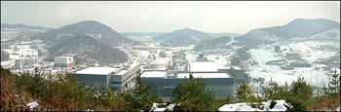
  Heyri Art Valley
  Address
  Gyeonggi-do, Paju City, Tanhyun-myun, Bupheung-ri, 1652 (within Tongil Dongsan)
  Type
  Alternative Experiences/ Streets
  Inquiries
  -Korea Travel phone +82-31-1330 (English, Korean, Japanese, Chinese)
  -Heyri Art Valley +82-31-946-8551~3 (Korean)
  Homepage
  http://www.heyri.net/ (English, Korean)

Introduction
Korean artists of various specialties such as writers, painters, actors, architects and musicians constructed the cultural town of Heyri. Within this community there are residents, workrooms, art galleries and museums. Artists make a living by opening exhibitions, trading or selling their art. Currently, there are about 40 museums, exhibitions, concert halls and bookstores and around 30~40 more are expected to be added. Currently about 10 cafes and food courts are included in these buildings for the convenience of the visitors.
Heyri Art Valley was constructed to blend in with surrounding structures. The local construction regulations require all buildings to be no more than three stories tall. Just by a glance at these buildings you will admire its artistry since architects constructed each building with its own unique characteristics.
HAS III Art Gallery and field of reeds by the central lake had been the filming locations of the romantic comedy, "Everybody Has Secrets (2004)" starring Lee Byung-hun & Choi Ji-woo.
Operating Hours
The Heyri Art Valley is open 24 hours. However, museums and exhibitions are open from 10:00am to 7:00 pm. Note that hours may vary slightly at each museum, and Museums with cafes and restaurants are open later.
Admission Fees
Entrance to the Heyri Art Valley is free. (admission fee charged from each museums and exhibitions)
Local Transportation
* At Exit no. 5 of Daehwa Station (Seoul Subway Line no. 3), walk to the bus station at the backside. Take bus no. 200 which comes about every hour. (1,400 won, 50 minute ride)
First bus runs at 7:50p.m., the last bus at 11p.m.

15. Korean Folk Village
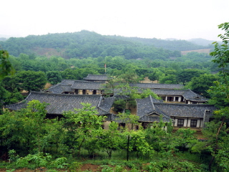
  Korean Folk Village
  Address
  Gyeonggi-do, Yongin-si, Giheum-eup, 107 Bora-ri
  Type
  Old Houses/ Birth houses/Folk Villages
  Inquiries
  -Travel phone +82-31-1330 (English, Korean, Japanese, Chinese)
  - +82-31-286-2116 (English, Korean, Japanese, Chinese)
  Homepage
  http://www.koreanfolk.co.kr/ (English, Korean, Japanese, Chinese)

Introduction
Set in a natural environment occupying approximately 243 acres, visitors can experience the natural atmosphere with over 260 traditional houses reminiscent of the late Joseon Dynasty, including various household goods from different regions. All these features have been relocated and restored to provide visitors with a broad undertanding of Korean food, clothing, and housing style of the past.
About twenty workshops, various handicrafts such as pottery, baskets, winnows, bamboo wares, wooden wares, paper, brass wares, knots, fans, musical instruments, iron wares and embroidery are practiced. In the Korean Folk Village, where the customs and lifestyles of the past generations have been carefully preserved, various lifestyles prevalent during the Joseon Dynasty can be seen.
You can visit the Folk Museum as well as the Art Museum (scheduled to open) to see and learn about the essence of Korean culture and folk customs, which are not suitable for display and re-creating in the open-air setting.
Korean Folk Village is also the filming location for the famous movie Scandal as well as the TV miniseries Daejanggeum.
Closed
None
Operating Hours
Dec-Feb : 9 a.m.- 5 p.m.
March : 9 a.m. - 5:30 p.m.
April : 9 a.m. - 6 p.m.
May-Sep : 9 a.m. - 6:30 p.m.
Oct: 9 a.m. - 6 p.m.
Nov: 9 a.m. - 5:30 p.m.
* Hours are extended by 30 mintues to one hour. Hours vary by season.
Admission Fees
Classification |  | Admission | Full Package | Museum Package
Adults | Individual | 11,000 won | 16,000 won | 14,000 won
Adults | Group | 9,000 won | 14,000 won | 12,000 won
Adolescents | Individual | 8,000 won | 14,000 won | 11,000 won
Adolescents | Group | 7,000 won | 13,000 won | 10,000 won
Children | Individual | 7,000 won | 13,000 won | 10,000 won
Children | Group | 6,000 won | 12,000 won | 9,000 won
* Adults: age 19 or over / AdolescentS: 13-18 / Children: 4-12
* Groups are more than 30 persons.
*Full Package: Includes fees for Admission, Korean Traditional Haunted House, Folk Village & World Folklore Village, Facilities in the Family Park.
*Museum Package: Includes fees for Admission, Folk Museum & World Folklore Museum.
Local Transportation
1. From Exit No. 2 of Moran Subway Station (Bundang Line), take City Express Bus (jwaseok bus) No. 1116 and get off at Korean Folk Village (70 minute ride).
2. From Exit No. 6 of Gangnam Subway Station (Seoul Subway Line No. 2) or Exit No. 7 or Yangjae Subway Station (Seoul Subway Line No. 7), take City Express Bus No. 1560 or 5000-1 and get off at Korean Folk Village (30-40 minute ride).
3. At front of Suwon Subway Station (Seoul Subway Line No. 1), take City Bus No. 37 or 10-5 or shuttle bus (by Aehyung Department Store). Or from Yongin Intercity Bus Terminal, take city bus No. 10-5 and get off at Korean Folk Village (one hour ride).
4. At Jamsil Subway Station (Subway Line No. 2) take City Express Bus No. 1116. (one hour and 10-20 minute ride)
5. 5. Shuttle Bus (Folk Village Office in front of Suweon Station)
Runs five time a day.(10:30a.m. 11:30a.m. 12:30p.m. 1:30p.m. 2:30p.m.), 30 minute ride.
16. National Museum of Contemporaty Art
Address
209 Gwangmyeong-gil, San 58-1 Makgye-dong, Gwacheon-si, Gyeonggi-do
Description
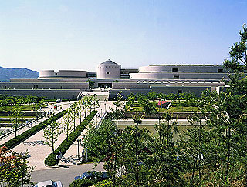
The National Museum of Contemporary Art is the one and only national museum where you can see Korean and foreign artwork in one place. It has world-class facilities and an outdoor sculpture exhibit. The gallery building was built to blend well with the Mt. Cheonggesan and the unique Korean landscape behind the gallery. The design was based on the old castles, walls and stairs of traditional Korean houses. Due to the delicate work, the museum itself can be called artwork. Besides appreciating the paintings and sculptures, you can find more information on the exhibited artwork and other art at the data library. You can buy souvenirs or crafts at the museum shop. If you get tired from the tour, you can rest at the lounge or you can dine at the restaurant at a reasonable price. The National Museum of Contemporary Art is close to the amusement park 'Seoul Land' and the zoo 'Seoul Grand Park'. Take a ride on the elephant train and you will be able to visit all three places.

Local Transportation
At Seoul Grand Park Station (Seoul Subway Line 4) exit No.4, take the museum shuttle bus and get off at the museum. To take the shuttle bus, you must buy the museum admission ticket from the ticket dispensing machines at the subway station.
*Exceptions: Admission free visitors
*Shuttle Bus: There is a bus every 20 minutes
① March~ October: Grand Park Station -> Museum. First bus 9:40, Last bus 17:00
Museum -> Grand Park Station. First bus 11:10, Last bus 17:50
※ Bus schedule is extended one hour on weekends
② November~February: Grand Park Station -> Museum. First bus 9:40, Last bus 16:00
Museum -> Grand Park Station. First bus 11:10, Last bus 16:50
Detailed Info
1. Telephone: +82-2-2188-6000(Kor)
+82-2-1330(Kor/Jpn/Chn/Eng)
2. Homepage: http://www.moca.go.kr(Kor/Eng/Jpn/Chn)
3. Hours: *Mar.~Oct.: 9:00am~6:00pm(Open until 7:00pm on Sat,Sun and Hoilday)
*Nov.~Feb.: 9:00am~5:00pm(Open until 6:00pm on Sat,Sun and Hoilday
4. Closed: Every Mondays; Jan. 1st
5. Admission Fee : *Ages 25~ 64 : 700won/
*19~ 24 : 300won/
* Under 18 , Over 65/Handicapped : Free /
* Every First Sunday : Free
6. Facilities: Archive, Children's Playroom, Museum Shop, Restaurant, Lounge, Wheelchair Rental Service, Lockers, Stroller Rental Service, Public Telephone

