(http://www.artnewcity.com/en/src/main.php)

SEWF2014
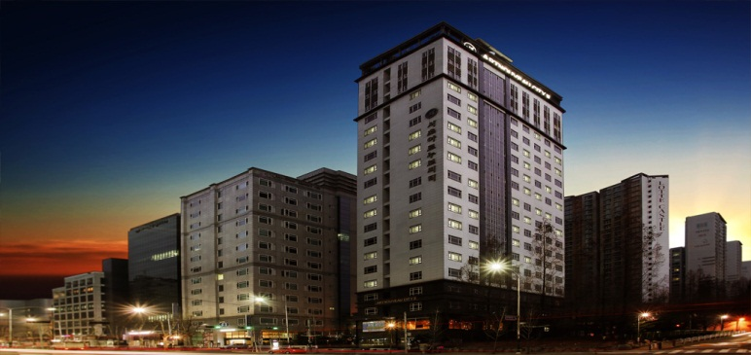

▶ Facilities : Room, Dining Room, Business Center, Sky Garden
▶ Internet Access: free wifi access in hotel
▶ Address : 1608-1 Seocho-dong, Seocho-gu, SEOUL, KOREA
▶ Phone No.: +82-2-560-7100
▶ Homepage: http://www.artnewcity.com/en/src/main.php
▶ Reservation E-mail : jaylee@artnewcity.com

- Guest Name :
- Check-In Date :
- Check-Out Date :
- Room Type :
- Number of Rooms :
- Card Holder’s Name:
- Credit Card Number / Expiration date:

▶ Morning buffet : 07:00AM~10:00AM
▶ Our check-in time policy is 3PM and our check-out time policy is 12PM.
▶ From the Incheon International Airport, No. 6020 Limousine bus takes you to Jin-Heung APT(Art Nouveau City Ⅲ Seocho)
(Further information, please refer to http://www.artnewcity.com/en/src/sub13.php )

If you have any queries, Our assistants will be happy to answer your queries.
please do not hesitate to contact us.
And we are looking forward to welcoming you.

If you cancel your reservation, you will incur a cancellation charge
▶ the hotel of cancellation 2 days prior : no charge for the appointment fee.
▶ the hotel of cancellation 1 days prior : we charge 50 percent of the appointment fee.
▶ the hotel of cancellation the day : we charge 100 percent of the appointment fee.

