(http://www.thek-hotel.co.kr/e_seoul/main.asp)

SEWF2014
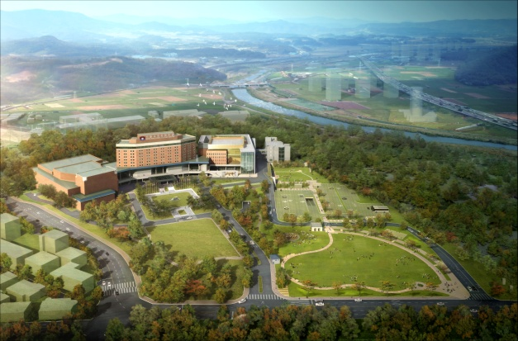

▶ Facilities : Restaurant,Bar,Bakery,Coffeeshop,GrandTheater,GolfRange,Beautysalon,
Barber'sshop,Conveniencestore,Jewelryshop'ZEN'
▶ Internet Access: Charged with fee (KRW 10,000) in the room, free wifi access in hotel lobby
▶ Address : 70, BAUMOE-RO 12-GIL, SEOCHO-GU, SEOUL, KOREA
▶ Phone No.: +82-2-526-9513
▶ Homepage: www.thek-hotel.co.kr
▶ Reservation E-mail : reservation@thek-hotel.co.kr

- Guest Name :
- Check-In Date :
- Check-Out Date :
- Room Type :
- Number of Rooms :
- Card Holder’s Name:
- Credit Card Number / Expiration date:

▶ Morning buffet : 07:00AM~09:00AM
▶ Our check-in time policy is 2PM and 30% of 1 night applies for early check-in before 2PM.
▶ From the Incheon International Airport, No. 6009 Limousine bus takes you to Yangjae subway station and it takes just 10minutes to the hotel by taxi.

If you have any queries, Our assistants will be happy to answer your queries.
please do not hesitate to contact us.
And we are looking forward to welcoming you.

If you cancel your reservation, you will incur a cancellation charge
▶ the hotel of cancellation 30 days prior : we charge 30 percent of the appointment fee.
▶ the hotel of cancellation 3 days prior : we charge 80 percent of the appointment fee.
▶ the hotel of cancellation the day prior : we charge 100 percent of the appointment fee.

